[Climate Engine](https://www.climateengine.org/) is an app that allows users to visualize climate data from many different places in one convenient place.

To get started with Climate Engine, go to their site and click the “Launch App” button.

From there, you will be prompted to log in. Click “Sign Up for FREE” and follow the prompts.

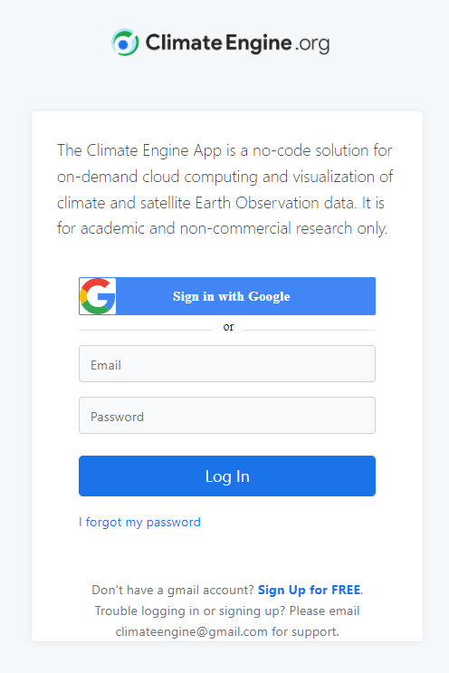

You’re in! With that, you’ll see lots of options to explore, with two different views, “Make Map” and “Make Graph”.

Today, we’ll be pulling data from the “Make Map” pane. Let’s go through the options one by one.

Since the other data we’re working with is a raster, we’ll keep this option as a raster as well.

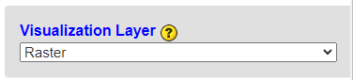

For “Variable”, I’m changing the Dataset to PRISM - 4km - Monthly:

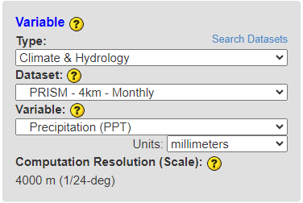

Feel free to add a calculation if you’d like:

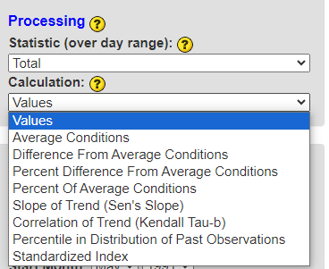

Lastly, enter your time period of interest. This is how it appears by default:

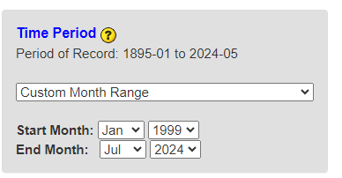

However, options will change depending on what “Processing” options you select. I selected “Average Conditions”, and selected the following:

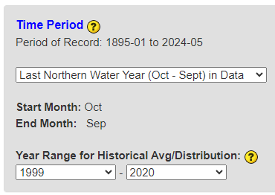

Click “Get map layer” and wait while the result loads.

To download, click the “Download” dropdown and select “Full Domain”. This will provide a box that you can resize to span your entire study area.

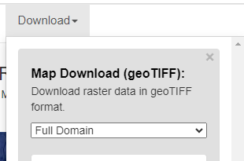

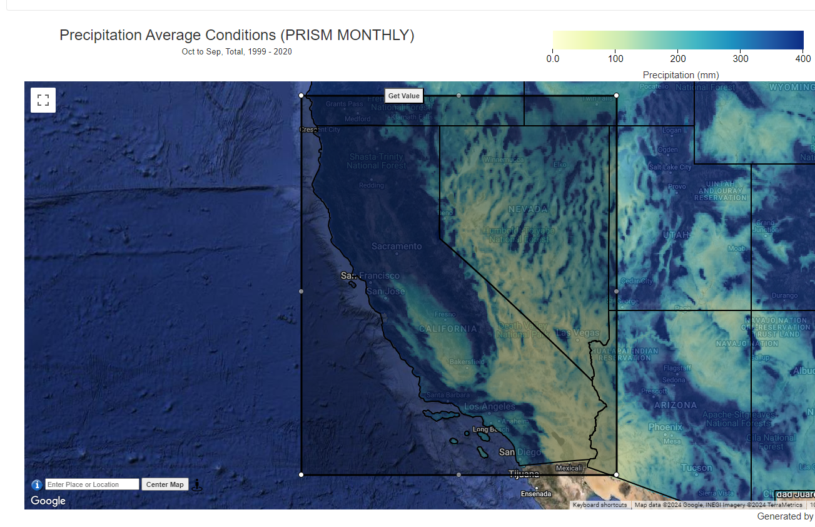

And then, you are ready to download!